


Project Navodaya

ABAP Technical Specification

Document Information

Document Number
Title | RAP Application for YRVR322
Document Purpose | Optimization of report YRVR322
Key Words
Document Status | Final
Contact for Enquiries | SARFRAZ

Document Change Control :
Release | Description | Created by | Date | Reviewed by | Date | Approved by | Date
01 | RAP Application for YRVR322 | SARFRAZ | 18-06-2025

Header
Area (R/3Module): | SD |  |  |  |  | Date: |  | 17-01-2025
Requested by: | GAIL SD team
Title: | RAP Application for YRVR322
Short description: | Optimization of report YRVR322
Functional Developer: | Pankaj Wadhwa (SAP) |  |  |  |  |  | Phone: | +91
Technical Developer: | Sayyad Sarfraz Ali |  |  |  |  |  | Phone: | +91 8827833896
Program name:
Type: | Change Request Development Request(Creation) Rework
Program type: (select the check box) | Conversion Batch Interface Online Interface Report  Form Enhancement Extension Dialog  Modification Unknown Others BAPI  ALE/ IDOC Application Development
Priority: | Very High High Medium Low
Complexity: | Very High High Medium Low
Specify known SAP functionality: |  | <Specify the related SAP transactions>
Cross Reference Documentation:
Only for Interfaces:  Type of interface:  Direction of interface:  Frequency: |  |  |  | Real-Time Batch  Inbound Outbound Both  Daily Weekly Monthly  Biweekly Other:
Only for Reports:  1. The report will be created via:  2. Requested characteristics: |  |  | Standard Report  Report Painter Report Writer ABAP Query  ABAP Program Info System  Drill-down Pushbuttons Sort  Entry files Others: _____________________
Generic question:  1. Impact of not creating the program: |  |  | legal requirements will not be fulfilled  lack of information required for the business  lose functionality compared to the old system  others: could have duplicate data entered into the system_
Development labor estimate:
Are there any alternatives in the standard system: |  |  |  |  | Yes No
Describe the alternative found:
Reason why this alternative was not acceptable: |  |  |  |  | Performance problems Complexity  Others: The transaction to initiate

Technical Specification
3.1. Technical Report Created:

Root CDS: Y_YRVR322
Entity Set: Y_YRVR322
Service Defination :
Service Binding :

Development Overview

Sr. No | Program Name | Transaction Code | Transport Request No | Dependency/ TR Sequence
1 | YRVR322_CPCB | YRVR322

Development Details

Code
Screen:
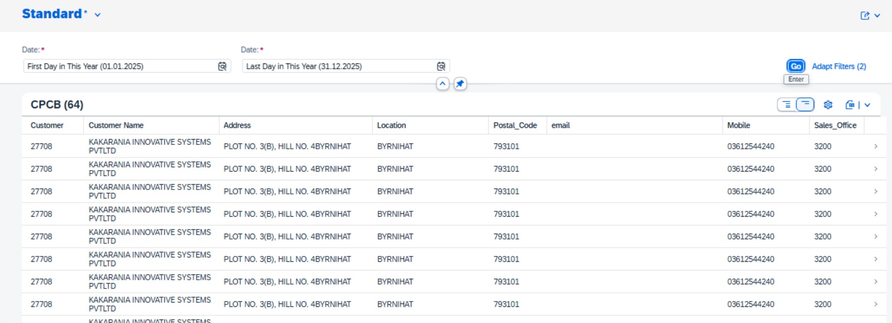

Logic:

1. CDS: V_KONV
This CDS view fetches the Number of the Document Condition, Condition item number, Step Number, Condition Counter, Application, Condition Type, Condition Basis * (n) based on value of Calculation Type for Condition and also case for TCURX- Number of decimal places, Currency Key, Condition exchange rate for conversion to local currency, Condition Pricing Unit, Condition Unit in the Document, Numerator for Converting to Base UoM, Condition Category, Condition is used for statistics, Scale Type, Condition is Relevant for Accrual, and many other fields from table PRCD_ELEMENTS joining table TCURX.
2. CDS: Y_YRVR322_KONV
This CDS view fetches from table VBRK, Billing Document Number from table VBRP, item number, Number of the Document Condition, Condition Basis based on Condition type and sum of Condition Basis by joining table VBRP based on Billing Document Number and CDS view V_KONV based on VBRP-Billing Item and VBRK- Number of the Document Condition where Billing Type is ‘ZP01’ or ‘ZP06’, Billing Date between the parameters p_from_date and p_to_date, Billing document is canceled equal to ‘X’ and IsDraft Indicator is initial from table VBRK, VBRP= Material Group equal to ‘FG0006’, and Condition Type in [‘JOIG’, ‘JOCG’, ‘JOSG’, JOUG’], Condition Amount or Percentage not equal to 0 of CDS view V_KONV. Group by on Billing Document Number, Number of the Document Condition, Billing Item, Currency Key, and Condition Type is used to avoid duplicate entries.
- CDS: Y_YRVR322_CALC
This CDS view fetches the Billing Document Number, Number of the Document Condition, Item Number, MAX of (IGST, CGST, SGST, UGST), and SUM of total from CDS view Y_YRVR322_KONV. Group by on Billing Document Number, Number of the Document Condition, and Item Number is used to avoid duplicate entries.
- CDS: Y_YRVR322_MID
This CDS view fetches the Billing Document, Sold-to Party, Max of ( Billing Date, Sales Office, Short text for sales order item, Customer Group, Material Number ), Sales Unit by joining tables VBRK and VBRP based on Billing Document Number, Billing Document Number, Number of the Document Condition, Item Number, IGST, CGST, SGST, UGST, and total from CDS view Y_YRVR322_KONV where Billing Date between parameters p_from_date and p_to_date, Billing Type is ‘ZP01’ or ‘ZP06’, Billing document is canceled equal to ‘X’ and IsDraft Indicator is initial, and Material Group equal to ‘FG0006’. Group by is used to avoid duplicate entries.

- Root CDS: Y_YRVR322
This CDS view fetches Billing Document, Sales Office, Material Number, UOM, Quantity, ugst, igst, cgst, sgst, supply date, total from CDS view Y_YRVR322_MID, Billing Item Number, Actual Invoiced Quantity , Customer number, Customer name, Address, Location, Postal Code, Email, Mobile Number, category based on Customer Classification, Tax Number 3 by joining tables VBRP, KNA1, ADR6.
- Metadata:
Once the data is fetched from the CDS, a metadata is created to define the UI of the fiori app.
7. Service Definition Exposure:
Once the metadata is defined for the CDS view entity elements, it is exposed through a service definition. This step makes the data accessible for external systems to consume.
8. Service Binding and Maintenance:
The service definition is bound and maintained. This ensures that the service is available to the desired applications and users.
9. Fiori Tile Creation and Role Assignment
A Fiori tile is created to display the data exposed by the service. Additionally, roles are assigned to ensure that only authorized users can access and view this tile.

Table Creation
N/A

Security /Authorization
N/A

User Exit
N/A

Transaction / Batch Job that will access enhancement
N/A

Anticipated performance Issues (if any)
N/A

Registration
N/A

Assumptions/ Notes

Unit Test Case
Screenshot for testing

- Report Screen:

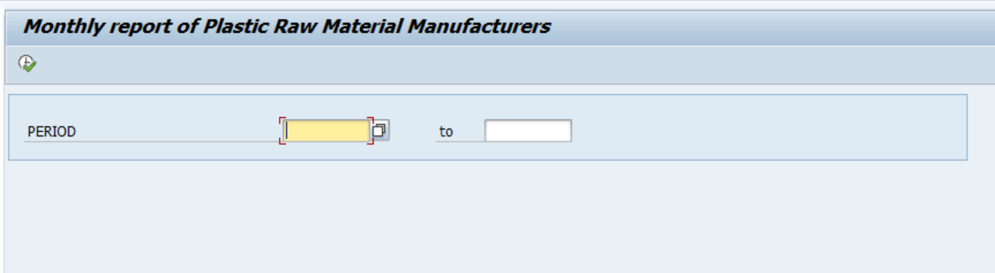
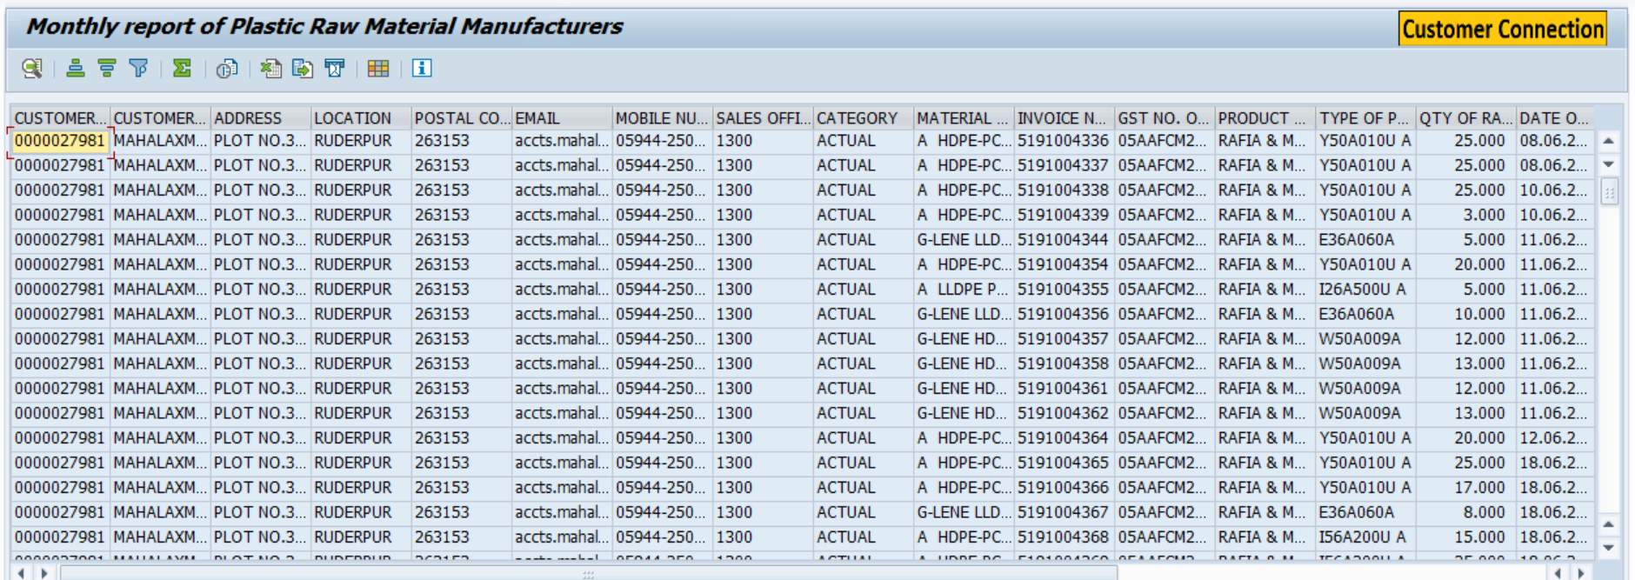

- Fiori Screen:

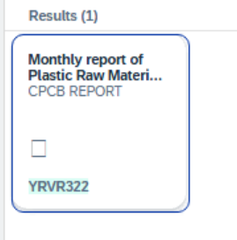



Technical Spec Original Sign Off:

Names and Signatures:

_____________Sarfraz_______________________________ Date: ___18/06/2025________

____________________________________________________ Date: _____________

____________________________________________________ Date: _____________

____________________________________________________ Date: _____________

Modifications
< Description of Modification if any>
<Support document of the modification like screen shot of email received>

